PE6 ACTION
MASTER PLAN for BICYCLING & WALKING
NORTH EAST & MILLERTON, NEW YORK
3 points

Contents of the North East & Millerton
Bicycling/Walking Master Plan

Goal and Background . . . . . . . . . . . . . 2
Geographical Circumstances . . . . . . . 5
Considerations . . . . . . . . . . . . . . . . . . 6
Ten-Year Action Plans . . . . . . . . . . . . 7
Walking Plan . . . . . . . . . . . . . . . . . . . . 8
Bicycling Plan . . . . . . . . . . . . . . . . . . 11
Signage Plan . . . . . . . . . . . . . . . . . . . .16
User Map Plan . . . . . . . . . . . . . . . . . .16
Steps Already Taken . . . . . . . . . . . . . 18
Resources, Guides, Protocols . . . . . 19

NORTH EAST & MILLERTON
CLIMATE SMART TASK FORCE
climatesmartmillerton.org

April 1, 2022

PE6 ACTION

MASTER PLAN for BICYCLING & WALKING

The Action Defined
"Municipalities should engage in a community-wide planning effort such as a bicycle and pedestrian master plan." —PE6

"Local governments can take a leadership role in increasing active transportation in their communities through planning initiatives and through installing infrastructure like paths, bike lanes, and way-finding signage." —PE6

Goal
Create a Bicycle and Pedestrian Master Plan for the Town of North East and the Village of Millerton that lowers greenhouse-gas emissions, increases equity, improves public health, stimulates the local economy and job creation, and enhances North East's sustainability. It has been shown that significantly increasing local bicycling and walking stimulate these beneficial effects on the community.

Background
North East is a rural community of 43.7 square miles, 98.7 percent of which is land. Total population of the Town and Village is about 4,000. The town has 3,000 inhabitants and a density of 70 people per square mile, compared to .62-square-mile Millerton with about 1,000 inhabitants and 1,613 people per square mile. Another 1,300 live within a mile of the Village, or more than 40 percent of the Town and 56 percent of all residents. Of a total of state, county, and local roads, the Town has 80 miles, the Village 7 miles. Elevation varies 1,781 feet from lowest to highest point, Brace Mountain, which is also the highest point in Dutchess County.

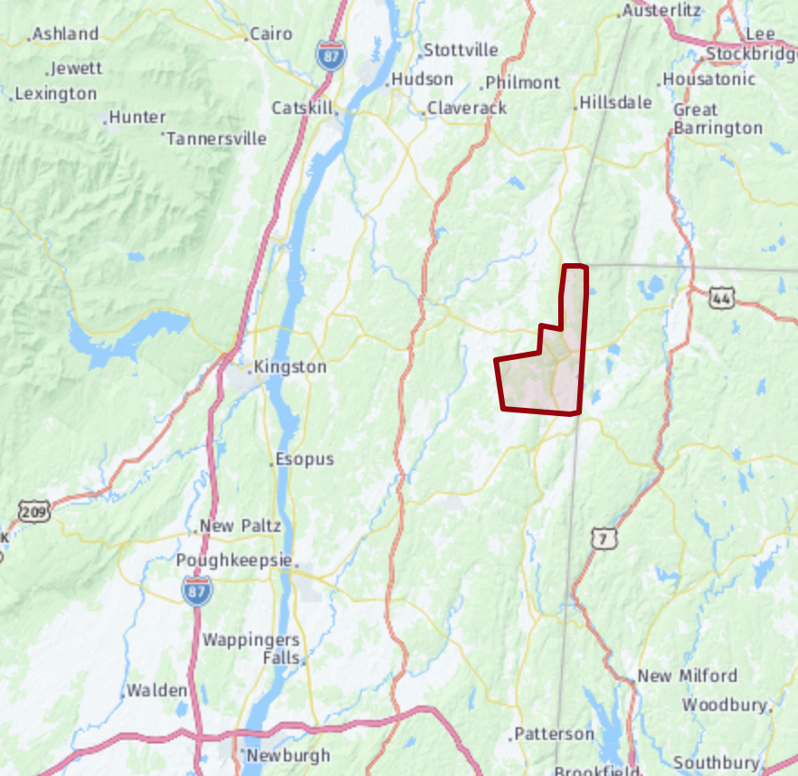
The community is no stranger to bicycling. Serious cyclers find the area appealing, and from Millerton south to Amenia the Harlem Valley Rail Trail has been in place since 1996. Nor is walking a foreign concept, as it can be in suburbia. Doing errands on foot and walking for recreation are common practice. Hiking is a popular pastime on numerous local trails and nature preserves, including the Appalachian Trail, which skirts the area.
Elevating bicycling and walking in the service of a cleaner, lower-carbon environment is an interesting and important challenge—one with certain opportunities and some circum-stances likely to meet resistance if not outright rejection. For example, many local workers commute long distances by car to their jobs, some of which are job sites. Opportunities to replace these car and truck commutes with self-propelled, human-powered modes of transportation will be limited. More likely is that these commuters will switch to electric vehicles, a process that has begun and will continue
Town of North East in relation to Connecticut, Massachusetts, and the Dutchess County seat of Poughkeepsie.
until the vast majority of drivers enjoy carbon-free
transportation. This at least will reduce the greenhouse
gases emitted by local people to and from their jobs.

Nevertheless, a cluster of employers in the Village is conveniently reachable by bicycle from the surrounding area, including retail stores, commercial offices, and one light manufacturer.

In addition, there are opportunities to convert local motorized vehicle trips to bicycle or walking for errands, chores, and visits. This opportunity will increase dramatically when the long absence of a local supermarket is filled with a new market in the same empty plaza, which is in the works. That should also draw new businesses to the plaza.

Employers beyond the core village, however, are not readily accessible by bicycle, being on two-lane 55mph state highways with narrow, soft shoulders or much trafficked roads with no shoulders at all. These notably include Harney & Sons headquarters south on Route 22, and the emerging business districts of Irondale north on Route 22 and the Boulevard east on Route 44. The Town's public K-12 campus is four miles south of the Village off Route 22. Virtually all students and teachers rely on school buses or private cars to and from school, unless they live in the neighboring hamlets of Perry's Corner.

The major challenge is the expense of adding bicycle lanes to existing macadam two-line roads that tend at best to offer only narrow shoulders. But as the area grows and gains population, such infrastructure for walking and bicycling must be planned, backed by government leaders, and ultimately paid for largely or entirely with county, state, and federal funds. After all, the benefits of cleaner air and lower energy use accrue to everyone.

The Town of North East and the Village of Millerton are fortunate to have the Harlem Valley Rail Trail (HVRT) running like an artery through the community. This nationally recognized, nonmotorized, paved, and augmented rural rail trail is the product of decades of work by local volunteers, the generosity of private citizens, and the vision of county, state, and federal
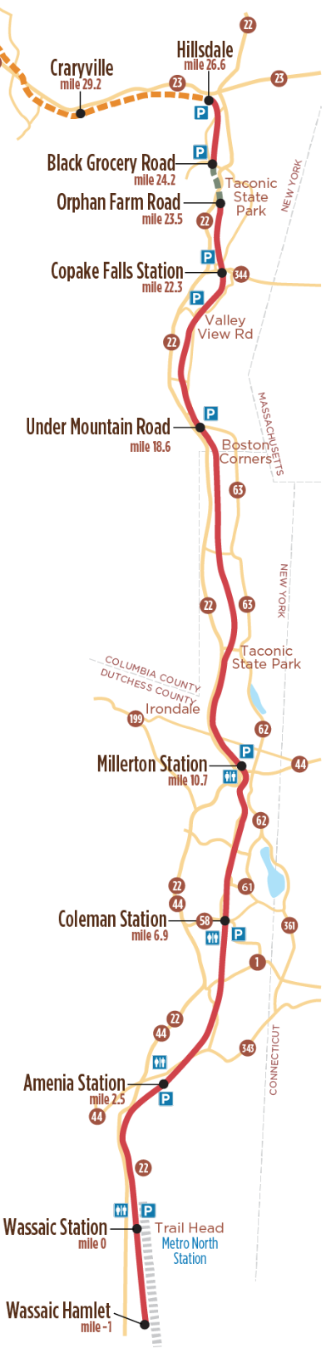
officials. Efforts began not long after the Harlem Valley Railroad, division of the New York Central, terminated passenger and freight service north of Dover Plains in the mid-1970s and removed the tracks, ties, and equipment from Dover Plains to Chatham.

As of 2021, when a glorious new eight-mile section was added north of the Village, the HVRT is a continuous asphalt trail for 22 miles, from the hamlet of Wassaic to two miles north of the Taconic State Park. It includes public parking at several intersections, numerous safety railings, road-crossing markers and signage, map displays, historical exhibits, toilet facilities at two locations, and an informative website maintained by the Harlem Valley Rail Trail Association. It is used by more than 100,000 people annually, according to HVRTA studies.

The culmination of the building of this Wassaic-to-Hillsdale stretch of rail trail will be the connection next year of another two-mile paved section from Hillsdale south by way of a designed and paid-for bridge over Route 22, for a grand total of more than 26 continuous miles through the communities of Wassaic, Amenia, Millerton, and Hillsdale and nearby villages in between.

While the HVRT preceded Climate Smart and continues under the able support of the HVRT Association to support carbon-reduction efforts, a member of the North East Climate Smart Task Force has been on the Association's board for many years and closely involved in its fundraising, trail mainten-ance, and organizational efforts. This assures close coordination between the North East and Millerton Climate Smart Task Force and the HVRT Association.

It therefore makes sense to base Climate Smart Task Force biking and walking plans for North East and Millerton on the backbone of this marvelous public resource, and in the process partner informally with the Harlem Valley Rail Trail

< The current Harlem Valley Rail Trail.
Gray dashes: to be completed in 2022-23.
Brown dashes: planned section.
Gray zipper: Metro North Railroad.

Association to strengthen this vital amenity's value to the community and the region. For example, it is proposed in the following that commuting south from the Village to employers and the Webutuck school campus can be made far more bicycle- and walking-friendly if commuters use the Rail Trail to an east-west intersection, then cut over to Route 22, where they can turn onto a paved walking and bicycling lane that stretches between Coleman and Sharon Station Roads, providing safe, no-carbon access to the Webutuck School campus and possibly the McEnroe Organic Farm Store.

Geographical Circumstances

The Town of North East is shaped like a pork chop with the bone pointed north. It is bordered by Connecticut to the east, Massachusetts to the northeast, Columbia County to the north, and several colonial-era or nineteenth-century small towns and hamlets to the west and south: Pine Plains, Stanford, Millbrook, and Amenia.

Along much of the Town's eastern flank stand the Taconic Range of ancient mountains with elevations of 1,000 to 2,000 feet above the valley floor. The major road, the two-lane State Route 22, runs north-south roughly three miles west of the state border. It is a truck route and at times heavily used by tankers, log carriers, garbage trucks, and commercial vehicles, and is hazardous for bikers. We do not believe bikers and walkers should use Route 22 until bike lanes and sidewalks or side paths are in place.

To the west of Route 22, forming the valley's western wall, are significant hills that extend toward the Hudson, a bumpy terrain of heavily eroded ancient upthrusts and terminal moraines interspersed with narrow valleys, meadows, and undulating fields. Biking and roadside walking in this area confronts steep, shoulderless climbs and descents, blind corners and a great variety of traffic from cars and trucks to farm machinery. However, just west of these ancient hills is excellent low-traffic biking, especially between Routes 82 and 83, in Smithfield and Shekomeko. This is worth exploring, but in a second or third phase.

From Route 22 east to the Connecticut state border lie several low-traffic country roads with easy grades and great views. This area is ideal for both biking and walking and includes the HVRT. This is where we will to concentrate our initial efforts.

Considerations

The need to reduce greenhouse-gas emissions grows ever more urgent. The pre-industrial level of carbon in our atmosphere was 270 parts per million. A healthy long-term level for human habitation in the biosphere planet Earth is up to 350 ppm, but we are now nearing a global 420 ppm, and the concentration of carbon is rising an average of nearly one point per year—and far faster than that above and possibly below the 60th meridians.

Every success against carbon emissions is important. Even small ones can set in motion a beneficial chain reaction. Such a noticeable improvement as new bicycling and walking infrastructure sends a powerful signal that a community is taking the climate crisis challenge seriously—particularly if such changes are exemplary. Reinforced by strong, targeted communications, advances will motivate other positive changes in the community, and be potentially motivating among visitors to Millerton's tourist attractions, a growing array fed by the new back-to-normal normal of an endemic Covid-19.

This rural area has three and possibly four corridors along which bicycles and pedestrians should be encouraged and protected. As the Town and Village grow in the next years and decades, these routes will become arteries. The time to accommodate nonmotorized commuting and inculcate the practice is now, before development forces expensive retrofits—or pushes improvements financially out of reach. In fact, as "Complete Streets" and other policies spell out, any roadway improvement for motorized vehicles should include facilities for bicycling and walking whenever feasible, whether they exist or must be added. The corridors:

- Route 44 east through the commercial Boulevard Districts West and East to the Connecticut state line
- Elm Avenue/State Route 22 north through the Irondale commercial district
- Elm Avenue/State Route 22 south past the Harney & Sons tea-packaging factory todz Route 199
- The Sharon-Millerton Road headed south from the light to the state line
- Continuation south on Route 22 to the McEnroe Organic Farm store, the Haight Road turn to the Webutuck school complex, and the Town line at Sharon Station Road, about six miles; or else just the stretch from Coleman Station to Sharon Station Roads (see Future Bicycling Actions page 14).

These paths are anticipated in the Town of North East's revised Comprehensive Plan of 2019. However, any one is a major undertaking well beyond the resources of the local government and of even sizable NGOs. With an influx of federal economic stimulus money now reaching the state and its counties, this is an excellent time to formally plan and fund these improvements. They are not difficult to design and build, and could be shovel-ready and approved in a relatively short time.

Bicycling & Walking Ten-Year Action Plans

With the notable exception of the Harlem Valley Rail Trail, the Town of North East and the Village of Millerton remain undeveloped in terms of bicycling and walking infrastructure for its two major potential users, local residents and tourists. While these two groups have different needs and interests, their congruences far exceed them.

Strategic Approach: Rather than the usual approach to public infrastructure—build it and they will come—North East will heavily involve the community from the outset and pursue what the community is willing to get behind and support, such as the initial social research Climate Smart has already undertaken. However, professional planners also have much to offer. They have learned how communities tend to grow, and how they should grow to maximize future health and prosperity for all. Our strategy is to find the best balance between community preference and the knowledge and experience of the planning discipline.

Assumption: Bicyclists and Walkers see and use the world differently. Plans to accommodate each set of needs and wishes should be developed separately, then brought together to maximize commonality and minimize expense and effort.

Challenge: Resolve the rapidly emerging use of electric-motor-assisted bikes, skateboards, scooters, trikes, hoverboards, unicycles (eWheels), and other such electrified personal transporters or vehicles (PEVs): Should they be encouraged to mix among walkers and muscle-powered machines or excluded? The experience of other communities and emerging state and big-city guidance will be eagerly sought.

Build a Multilayered Master Bicycling & Walking Planning Map
Key to this process will be an updatable GIS-based master digital bicycling and walking map of the Town built in collaboration with the map experts at the Dutchess County Department of Planning & Development. In fact, this process is well underway. Our current tool as four layers in digital form: roads and boundaries, terrain, satellite imagery for structures, and an overlay for the planned bicycle and walking features to be added, including:

> Alternate routes off and on the HVRT for scenery, exercise (hills), points of interest, services, etc.
> Actual and potential commuter routes—back roads to and from work and services (shopping, groceries, destinations) where little traffic will be encountered.
> Parking areas to accommodate bicyclists and walkers along the HVRT.
> Needs in the Town and Village for HVRT accessories: POI signs, wayfinding signs, mileage signs, facilities, water sources, bike racks, repair racks, emergency calling with locations (bikers need to tell EMS or police exactly where they are), weather shelters.
> Work with HVRTA to design, pay for, construct, and install accessories.

Walking Action Plan

Millerton has the most sidewalks of any community in Dutchess County at 21.6 feet per resident, yet there are many gaps, ADA shortfalls, and yards of concrete in need of repair. North East has the fewest sidewalks in the county, and while it is largely rural, accommodations for walkers could be much improved.

A detailed Pedestrian Plan for the Village of Millerton was produced in 2018 by the Dutchess County Transportation Council (46 pages plus six appendices). It was financed in part through "grants from the Federal Highway Administration and Federal Transit Administration, U.S. Department of Transportation, under the State Planning and Research Program, Section 505 for the Metropolitan Planning Program."

This plan has been and will continue to be a vital part of the planning process for bicycling and walking in Millerton and North East.

Identify, Quantify Needs and Reasonable Community Wishes
The Millerton Pedestrian Plan researched the walking habits and needs of Millerton pedestrians thoroughly enough that this need not be repeated.

Before any significant changes are begun, it is important that the community compile all existing relevant legal, technical, and procedural input and guidance, including NYSDOT laws and regulations, ditto for the county and any local ordinances, sections of state and county planning manuals, ADA laws, and local zoning laws, the North East Comprehensive Plan 2019, and the Climate Smart Task Force's 2021-22 Community Climate Survey.

ACTIONS SUGGESTED FROM EXISTING PLANS

The Millerton Pedestrian Plan recommends the following actions. Our notes in italic.
- Conduct a safety assessment on Route 44 (Main Street) in Millerton.
- Reduce speeds and improve shoulders to accommodate bicycles along CR 62 (Rudd Pond Road) between the Taconic State Park entrance and the Village of Millerton.
- Provide signage to direct visitors to parking lots for the Harlem Valley Rail Trail in Millerton. Signs exist but need to be incorporated into the Uniform Signage Design system to come and may need improved siting.
- Complete the Harlem Valley Rail Trail (Stage IV) from Millerton to Columbia County. Essentially complete as of Q3 2021. A final link, a bridge over Route 22, is scheduled for 2022. Numerous accessory improvements to come, as indicated herein.
- Create a rail trail on the former Hucklebush Rail Line between Rhinecliff and the Harlem Valley Rail Trail in Millerton passing through Rhinebeck, Red Hook, Milan, Pine Plains, nd and a stop in North East (UF-75). Feasibility study required. 10 to 20-year horizon. Should accommodate two-wheel electrically motorized personal transportation.
- Specifically, the Plan identifies 11 issues and 25 suggestions (p20>). These should be examined in detail and, if feasible and desirable, proposed to Town and Village governments.
- Part IV of the Millerton Pedestrian Plan offers a good starting point for roughly estimating costs and for sources of county, state, and federal funds. Add to above proposed ideas.

The Walk-Bike Dutchess plan recommends the following actions. Our notes in italic.
- Repair State-owned, non-ADA compliant sidewalks and ramps (PB-1):
  - Main Street intersection at John Street
  - Main Street intersection at Central Avenue—Completed.
  - Main Street intersection at North Maple Avenue & South Maple Avenue
  - Main Street sidewalk from Dutchess Avenue to Park Avenue—Completed.
  - Main Street sidewalk from Central Avenue to North & South Maple Avenues
- Other recommendations include the following:
  - Millerton should develop an ADA Transition Plan for their streets and sidewalks, identifying improvements needed to make all streets accessible per ADA standards and a timeframe for implementing them.
  - Village/hamlet cross-section safety guidelines, intended to cover Route 22 within the village, require a sidewalk on both sides of the street.
  - Safety Improvements at Route 22/44 Intersection are needed, as trucks have trouble turning right from Route 22 northbound onto Route 44. A detailed study of this location is recommended, including documentation of the frequency of truck turns, vehicle size, pedestrian activity, and a crash analysis.
  - To improve available parking, incorporate access management tools into site plan review and subdivision regulations. Encourage shared driveways, shared parking lots, internal parking-lot connections, and parking on the rear or side of buildings.

PRIORITY WALKING ACTIONS

State Road Signalized Crosswalks
Since crosswalks are necessary for safe travel across a busy state road and the state's involvement is time-consuming, these should be at the top of the list:
- Across State Route 22 to reach Eddie Collins Community Park
- Across State Route 44 at Millerton Plaza

Connection Between Eddie Collins Park and the Rail Trail
This walking and bicycling route will reduce the number of vehicles driving to the park and increase the number of park users by improving safe access. There are several possible connections. Ideally the route does not involve North Elm/22 except to cross it. Coordinated planning between the Village, Dutchess County, and New York DOT should result in a signalized crossing of 22 and a route that is as direct as possible to or from the Rail Trail. Research into the feasibility of the potential routes should begin immediately.

It is recommended that the Town and Village develop a capital program for the growth and maintenance of sidewalks until there is at least one sidewalk per street and ideally one on each side of the road, particularly in the vicinity of major intersections. The Millerton Pedestrian Plan should be the starting point, and can help prioritize, being based on expert inspection of the Village and interviews with residents, the two highway departments, and county engineers (12a, p39).
- Within a decade, no street in the Village or immediately adjacent Town roads should be without ADA-compliant sidewalks on both sides of the road. Concrete should be the standard; as funding permits, asphalt should be replaced by concrete.
- Zoning and Planning: Significant development of any property with street frontage should include installation of an ADA-compliant sidewalk to match adjacent or nearest sidewalk nd adhere to Village and Town sidewalk specifications, at the developer's expense.

Bicycling Action Plan

Identify, Quantify Needs
Complete these three approaches and combine them.
Where do people bicycle in the Village? In the Town? Do they commute by bike? Run errands?
Action 1: Design a small study that employs observers at key points over several days. Include interviews of every tenth bicyclist or so about local biking habits and potential biking if circumstances were different.
Action 2: Analyze bicycle plans of other communities of similar or somewhat larger size and geographic circumstances. Examples: Rhinebeck, Red Hook, Saranac Lake? Quote applicable ideas and executions. Research planning experiences of similar municipalities along State Route 22—in particular Copake, Dover, and Hillsdale.
Action 3: Compile all existing relevant legal, technical, and procedural guidance, including NYS DOT laws and regulations, ditto for the county and any local ordinances, sections of state and county planning manuals, ADA laws, and local zoning laws.

Identify Reasonable Community Wishes
Where would people bike if improvements made biking easy and safe? How can bicycle commuting become more appealing?
Action 1: Compile all useful answers from Action 1 above; add ideas from other communities discovered in Action 2 above; add requirements from Action 3 above.
Action 2: Consolidate the tasks into a list that represents in raw form the Town's and Village's bicycling infrastructure needs for the foreseeable future.

ACTIONS SUGGESTED FROM EXISTING PLANS

Suggestions from Dutchess County's Millerton Pedestrian Plan (p9>). Our comments in italic.
- Evaluate Route 44 as a State Bicycle Route and designate/sign if feasible (PB-2). The NYSDOT has "identified Route 44 as a potential future State Bike Route" (8c p35).
- Install bicycle parking [Ph1, 8a]. The first bike rack under Climate Smart is being installed Q2 2022. See planned locations below.
- Provide bicycle wayfinding signage [Ph1, 8b]
- Connect the Harlem Valley Rail Trail with Eddie Collins Park. (See "Connection Between Eddie Collins Park and the Rail Trail," page 9.) Planning for this important connection should begin immediately.

PRIORITY BICYCLING ACTIONS

Bike Lanes and Road Shoulder Improvements
For several reasons, these two projects should be the top priority among the major ideas presented here. A first step is to consult with appropriate county and state officials about their feasibility and effective strategies to achieve them.
- Elm Avenue North/State Route 22: to the entrance to Eddie Collins field initially, then to Beilke Road in North East, going north the next bridge crossing of the Webatuck Creek. The west side has an existing sidewalk; it should be inspected and brought up to standard. The east side requires a sidewalk from the 22/44 light to Beilke Road, as funds permit.
- Elm Avenue South/State Route 22: from the Village to Route 199, to facilitate bicycle commuting to and from Harney & Sons as well as houses and commercial establishments such as Silamar Farm Stand along the way. Harney & Sons has nearly 300 employees as of mid-2022. Replacing a significant number of Harney commuting cars with bicycles, manual or electric, is an achievable goal.
- Boulevard District West and East, from the Maple Avenue/Route 44 light to the state line—depending on progress in the commercial revival of Millerton Plaza.

Parking Areas for Bicycle Use
Include in all parking areas: imperviable parking surface, shade trees, trash/recycling bin, bike rack, repair rack, picnic table with benches, portable toilet, water dispenser
- Intersection of HVRT and Rudd Pond Road, once Mt. Riga Station for the Harlem Line.
- Intersection of HVRT and Sharon Station Road
- Intersection of HVRT and White House Crossing Road as a first phase (see entry below).

Bike Racks
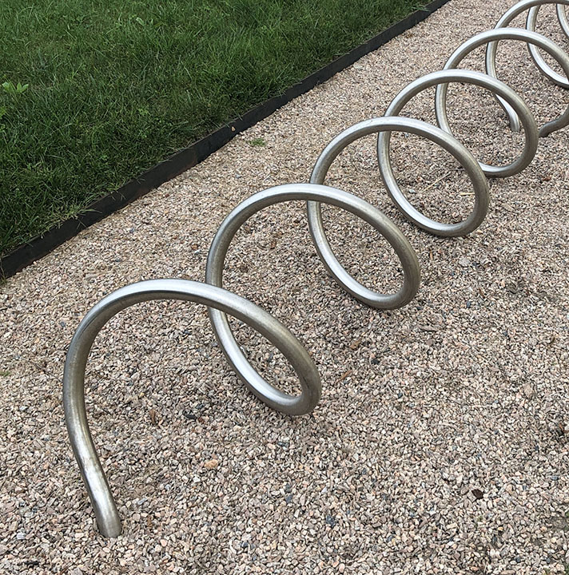
This corrosion-resistant steel rack design has been selected for the Town of North East. Locations 8 to 10 require installation by the county or state.
- Between Town Hall and the Post Office, to the east of the Century Boulevard driveway exit (ordered, not delivered)
- Library, center of front yard near sidewalk
- South Center Street in HVRT Parking Area, near the bike repair station
- Railroad Plaza next to the water station
- Irondale School and Harlem Valley Rail Trail
- Veterans Park, near the sitting area
- Coleman Station Rail Trail Parking Lot
- Intersection of HVRT and Sharon Station Road
- Intersection of HVRT and White House Crossing Road
- Intersection of HVRT and Rudd Pond Road

Town of North East Bike Routes—North

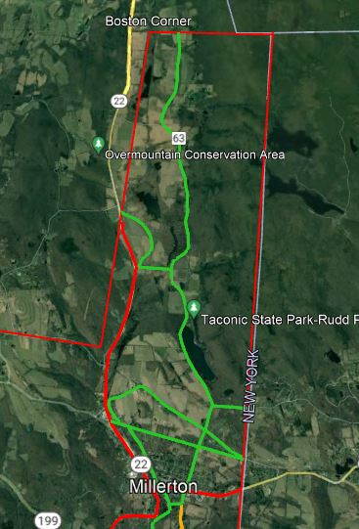
— Rural Bike Routes. These are mostly Town roads. Low traffic volume precludes the need for bike lanes at this time.
— County Highways. Traffic volume is a possible hazard for bicycles. Add Share the Road signs now, plan for Bike Lanes in five to ten year.
— State Highways. Substantial traffic, high speeds, and many trucks. Cyclists (and pedestrians) should exercise extreme caution. As is, these roads are poorly suited for bicycle commuting. While classified as official state bike routes, bike lanes should be added at the next major resurfacing.
Town of North East Bike Routes—South
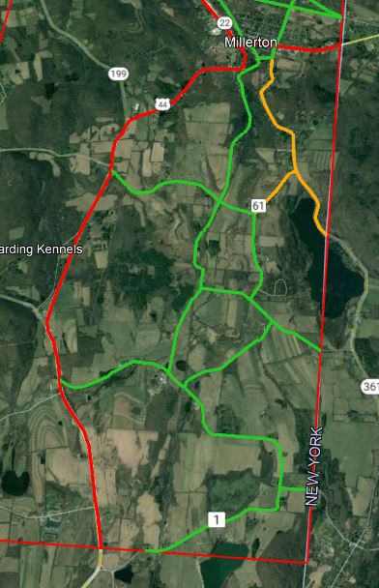
— Rural Bike Routes. These are mostly Town roads. Low traffic volume precludes the need for bike lanes at this time.
— County Highways. Traffic volume is a possible hazard for bicycles. Add Share the Road signs now, plan for Bike Lanes in five to ten year.
— State Highways. Substantial traffic, high speeds, and many trucks. Cyclists (and pedestrians) should exercise extreme caution. As is, these roads are poorly suited for bicycle commuting. While classified as official state bike routes, bike lanes should be added at the next major resurfacing.
Future Bicycling Actions
- "Traffic-calming" installations in Village such as at the pocket park at Main and Park Streets (see Millerton Pedestrian Plan [MPP])
- A bicycle- and walk-only street or street section in Village center (see MPP)
- Parking lot with amenities at Rudd Pond Road and the HVRT; property has been acquired.

Expanded, Full-Service HVRT Rest Stop at White House Crossing
It is proposed that this area, already designated for RT parking, be expanded to include a full-service rest stop with the following:
- Parking on imperviable surface
- Toilet facilities, composting (ideally) or port-a-potty
- Space for two food trucks and a picnic area with tables, water fountain, trash/recycling container
- Emergency call box connected to EMT, Sheriff, 911
- Water refilling
- Information signage on the Mount Riga stop, the HVRR, local fauna and flora, local geology, connections to the HVRT Bridge to Nature
- Camping, small scale, perhaps three tent sites with fire pits (clear with NYSPRHS).
- Locked Storage
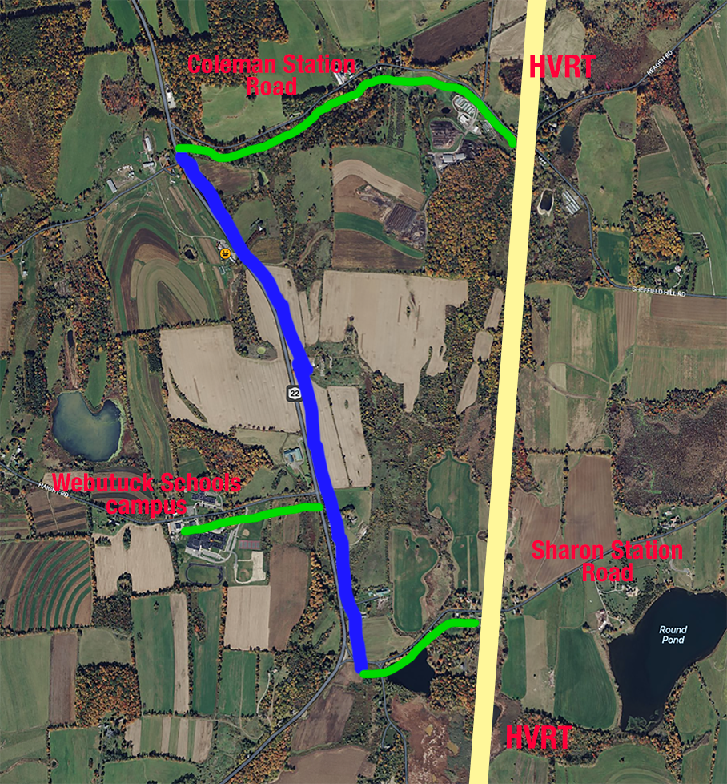
Multimodal Bicycle Commute
Virtually all Webutuck students, teachers, and visitors travel to and from the school district campus on Haight Road by car or bus. But the HVRT is only about mile away and little-used macadam roads connect the Trail to Route 22 (Coleman Station and Sharon Station Roads). A state-funded bike lane added to Route 22 between these two intersections would connect the campus to the Trail, for safe commuting via side roads. It would also serve the popular McEnroe Organic Farm store and restaurant. A crosswalk seems indicated either at the
two intersections or at Haight Road, depending on which side of Route 22 the bike lane was laid.
— Proposed paved bicycle lane along Route 22,
separate from traffic for maximum safety.
— Macadam. Share the Road signs recommended.
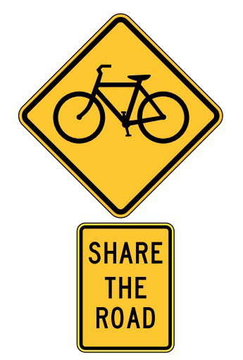
Signage Action Plan
Adhering to road-sign regulations and criteria stipulated in the NYS Highway Design Manual, develop sign priorities and a branded signage design system. Initial effort: Install "Share The Road" signs at appropriate places around the Town and Village, starting with the following locations. All 9 are on Town or Village roads, to occur in two phases, starting with signs 1 through 4. The remainder to follow in phase 2 after bike lanes are installed on affected state routes (see following page for aerial photos of locations):
- Boston Corners Road (Route 63) south of the Town line
- Rudd Pond Road (Route 62) south of Merwin Road
- Maple Avenue (Route 62) south of Fish Street
- Before Sharon Road (Route 62) becomes Millerton Road
(Route 361) along Indian Lake near the state Line
- White House Crossing before Route 22
- Old Post Road #4, at the Town border, before Route 22
- Intersection of Shagroy and Rudd Pond Roads
- Intersection of Main Street and Elm Street/Route 22
- West of the NY/CT state Line on Route 44

In addition, on the HVRT, add point-of-interest signs, wayfinding signs, mileage signs. First develop this Design-Build-Install Plan, in consultation with the HVRTA and either Dutchess County or the State Department of Parks, Recreation, and Historic Preservation:
- Determine sign purposes and wording
- Obtain approval for designs and locations with appropriate local, county, and New York State officials
- Fundraise/write grants
- Have signs fabricated
- Work with appropriate government highway department to site to install signs

User Map Action Plan
A vernacular, possibly hand-drawn map of North East and Millerton walking and bicycling routes, facilities, and accessories will be available online in scalable form, for use with screens as small as watches up to large TVs and also in hardcopy, for desktop printing, and inclusion in promotional material. It will include all of the user-relevant information from the Master Map. It will be paid for either by grant or advertising from local merchants (or both).
Share-the-Road Signs, Phase 1
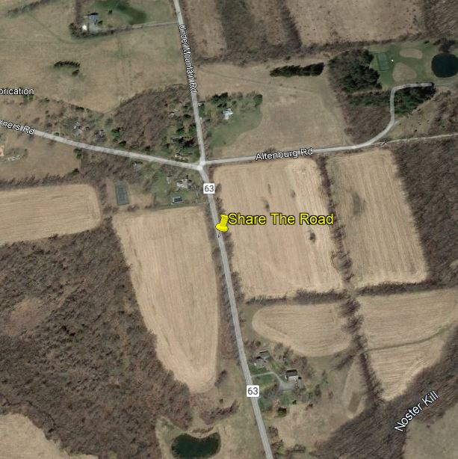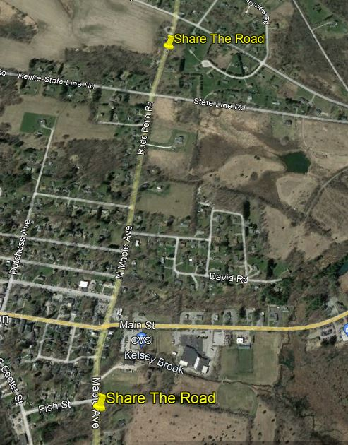
1 2 and 3

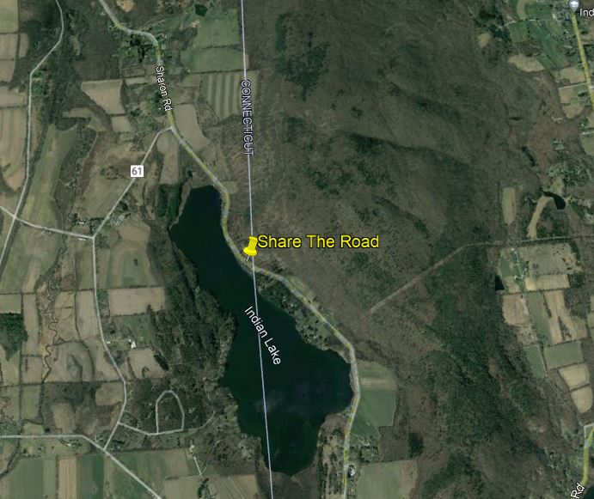
4

Steps Already Taken
Establish government support for the initiative
- Resolution supporting a "Climate Education & Engagement" program. DONE passed by Town Board vote 12-9-21
- Resolution adopting "Complete Streets." DONE passed by Town Board vote 2-10-22

"Walk-Bike Dutchess" [2014] recommendations:
- Amenia & North East: "Extend the Harlem Valley Rail Trail south to the Wassaic hamlet [one mile]." DONE Completed by Town of Amenia Q2 2020

Actions Pending
- Improve bike parking — installation of new racks for U.S. Post Office/North East Town Hall, accommodating up to eight bikes, mid-2022.
- Improve bike and pedestrian signage [2 points]—Nine "Share the Road" signs to be purchased and installed on Village and Town roads by the respective highway departments in two phases, starting mid-2022.

Actions Planned but Deferred
- Expand and improve bike/walking paths, bike lanes, sidewalks [3 points]—
The Town has three and possibly four corridors along which pedestrian and bicycle use should be encouraged and protected. As the Town surrounds the Village, these are obvious routes beyond the Village line along which pedestrians and bicyclists might travel:
- Route 44 east through the commercial Boulevard Districts West and East to the Connecticut state line
- Elm Avenue/State Route 22 north through the Irondale commercial district
- Elm Avenue/State Route 22 south past the Harney & Sons factory to Route 199
- The Sharon-Millerton Road headed south from the light to the state line
- Continuation south on Route 22 to the McEnroe Organic Farm store, the Haight Road turn to the Webutuck school complex, and the Town line at Sharon Station Road, about six miles; or else just the stretch from Coleman Station to Sharon Station Roads (see Future Bicycling Actions page 14).

Sidewalks and bike lanes for any of these are major undertakings beyond the resources of our local governments and NGOs. However, they are anticipated in the Town of North East's revised Comprehensive Plan of 2019. The Task Force plans to investigate these possibilities, develop proposals, and seek funding in coordination with relevant Town and Village entities including the Town's Business Development Committee, Supervisor Planning Committee, Highway Department, the Village Mayor, Planning Board, and Highway Department. Because these involve Dutchess County or New York State roads, those highway departments will be intimately involved in design and responsible for construction.
Resources, Guides, and Protocols

Comprehensive Plan for North East and Millerton, 2019
townofnortheastny.gov/comprehensive-plan-2019

Millerton Pedestrian Plan, 2018
climatesmartmillerton.org/wp-content/uploads/2021/03/Millerton-Pedestrian-Plan_2018.pdf
A 68-page Pedestrian Plan for the Village of Millerton was produced in 2018 by the Dutchess County Transportation Council. It was financed in part through grants from federal and state grants. This plan has been and will continue to be a vital part of the planning process for Millerton and North East, except for revisions to the plan to fix the following:
- The survey for Century Boulevard was measured incorrectly; the plan calls for a much wider street with a median, a more ambitious idea than necessary.
- Revisions to Century Boulevard recommendations to include a realistic evaluation of driving, parking, bicycling, and walking patterns around the Millerton Post Office.

NYSDOT Complete Streets Report, 2014
dot.ny.gov/programs/completestreets
New York State’s Complete Streets Act went into effect February 15, 2012. It embraces the needs of all users of our roadways, including pedestrians, bicyclists, transit riders, motorists, and people of all ages and abilities. The New York State Department of Transportation (NYSDOT) is committed to evaluating all the forms of transportation that are widely recognized to support economic growth, safety, and sustainability goals. This report highlights policies and programs, best practices, and next steps for furthering Complete Streets in the state.

Moving Dutchess 2: The 25-Year Transportation Plan for Dutchess County, 2016
dutchessny.gov/pdctc.htm
Poughkeepsie-Dutchess County Transportation Council. Note especially Chapter 6-5, "The Harlem Valley," pp270-92.

NYSDOT Highway Design Manual (current)
dot.ny.gov/divisions/engineering/design/dqab/hdm

Small Town and Rural Multimodal Networks, 2016
fhwa.dot.gov/environment/bicycle_pedestrian.
Alta Planning + Design, Small Urban and Rural Livability Center – Western Transportation Institute, National Association of Counties. ". . . a bridge between existing guidance on bicycle and pedestrian design and rural practice . . . [with] peer communities and project implementation appropriate for rural communities."

Walk-Bike Dutchess: The Pedestrian-Bicycle Plan for Dutchess County, 2014
dutchessny.gov/Departments/Transportation-Council/Docs/bppchaptersall.pdf
This is a 20-year "vision for improving walking and bicycling conditions in Dutchess County and aims to address the gap between our goal to make these activities a greater part of everyday life and the current limitations of our built environment." Key excerpts p242 >.

"Millerton Pedestrian Plan," Dutchess County Transportation Council, 2018, p2
"Moving Dutchess 2," Poughkeepsie-Dutchess Transportation Council 2016, p276
"The Villages of Tivoli and Red Hook have pattern books that could serve as models, and the County Planning Department’s Greenway Guides could be incorporated" [Millerton Pedestrian Plan 11g, p38].

